READ ME FIRST

This DEHS dataset contain the enumeration from 311 enumeration area(EA) out of the planned 660 EA. The data obtained from this version contain 3063 HH out of 6600 planned HH (46%) of the sample
Geographical Location
To obtain geographical information of the household s, please refers to “BUKU1COV.dta” , there you will find geo location from province until desa. Additional geograpgical information in form of island and urban agglomeration definition could be found on the following variables: island, metroname_new, coreperiphery_new ,singlemultiplemetro_new.

Wealth Estimate
Due to lacking consumption module, the DEHS data is equipped with 2 deciles estimate which could be found on “deciles.dta”. Two estimate of welfare deciles is created using PMT approach and asset index approach. A test using Susenas March 2019 data of these approaches created a total correctly classified deciles that almost the same between two approaches (but with different precision across deciles between the approaches). One note that also note to be taken, is that the weighted asset index decile is less smooth at the top 30% of the distribution (please figure 1, below), which create unequal split of household at the top

Figure1. deciles comparison between PMT and Asset Index approach
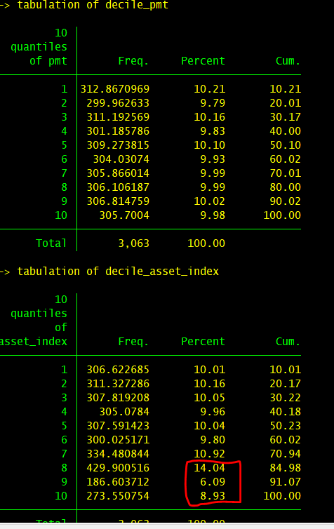

Weight and representativeness
To create a population representative statistics, an inverse probability weight (frequency weight) has been devised and could be found at ”dehs_final_weight.dta” under the name of “wgt”. The weight is unique at wilcah(enumeration area) level so merging of the weight should be conducted using the wilcah variable. As the weight contains fraction please use “aw” option rather than “fw” option when calulating your statistics. The weight will be able to provide you with representative statistic at national and urban rural dissagregation. Beside the weight we also provide you with the sampling information that could be found in “strata1” “su1” “fpc1” “su2” “fpc2”. These variables could be use to calculate the correct standard error (if you need one) or to calculate cv or rse. I would suggest you to use svy command and use these extra information if you conduct regression analysis. Lastly. Please be aware of rare cases statistics, while the weight will provide representative stat at national and urban rural for most of our indicators it wont be the case of rare statistics. As rule of thumb a rare statistic mainly occur if you create a statistics from less than 5% of the nationally representative data. But to be precise you could always use the relative standard error or cv. If you stats results 20-25% RSE, you should doubt the representativeness of the statistic that you’ve produced .

For instance, what is the proportion , standard error, and cv for population by gender in our data
use "BUKU1_AV.dta", clear
merge m:1 wilcah using "dehs_final_weight"
svyset su1 [pweight=wgt], strata(strata1) fpc(fpc1) vce(linearized) singleunit(centered) || su2, fpc(fpc2)

*proportion by gender
svy: prop av_4
estat cv

